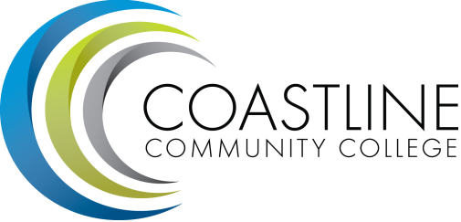

Classified Senate Meeting Agenda
Thursday, November 20, 2014
10AM-12PM
4th floor conference room, College Center

Approval of Minutes (5 minutes):

Fundraising Update (10 minutes):
  - Thank you to M&O, all donors, and participants for a successful Fall Festival.
  - Fall Festival.
  - Thirty-one Gifts.
  - Paints Uncorked.

Holiday Boutique.

Presentation by the Foundation (10 minutes):

Announcements (10 minutes):
  - Spring All-College Meeting @ the Rose Center, Feb. 20, 2015
  - Conferences: If there are conferences that will increase your value to the college, be sure to request funding, either from professional development or the Instructional Planning Council.
  - LMS update: In the hands of the Chancellor and Board.

Committee Reports (10 minutes):

Hot Topics (10 minutes):

Next Meeting: January 15, 2015

